WAALI Procedures

Admin Duties
Answering the phone:
- Follow guide on admin resources folder. Pg 1
Getting Mail: Refer to maps of CAT busses in Admin resources folder
- Catch Green CAT buss across the road
- Get off at Mill Street and walk up escalators into cloisters square, Australian Post
- Unlock po box number 7021.
- Once you have collected the mail go back down to escalators and cross the road to the green CAT bus stop stand in front of the NAB Bank.
- Get off at Sutherland street.

Continue to update Document’s regularly.
Laminating Register & Printing Register:
- SharePoint>ADMINISTRATION>Procedures>Photocopy register
Stationery Order:
- SharePoint>ADMINISTRATION>Office supplies> Stationery Order list
Office Inventory:
- SharePoint>ADMINISTRATION>Office Supplies>Inventory of office
Asset Register:
- SharePoint>ADMINISTRATION>Office Supplies>Asset register
Risk register:
- SharePoint>ADMINISTRATION>Procedures>copy of risk register
Staff:
- SharePoint>ADMINISTRATION>Staff
Only update when new staff members come in or current staff members resign.
When new staff join you will need to save a scanned copy of relevant documents such as, their signed contract, personal detail forms, performance review forms, signed code of conduct as reference under their name as an electronic copy.
You will also need to write up notes from staff meetings and save document on
SharePoint>ADMINISTRATION>Staff>meetings

Admin Duties

Walk in Procedure everyday:
- Turn lights On
- Clean any rubbish or cups/plates that may be on anyone’s table to ensure everyone walks into a clean office.
- Water the plants
- Fill the glass mugs up with water.
Close up Procedure:
- Ensure to clean any rubbish or pack away cups/plates left out.
- Shut down Computer (only on Fridays)
- Turn printer off (only on Fridays)
- Sit the plants in area where they will get sun light only (on Fridays so that they can get sunlight during the weekend).
- Lock office when leaving

ACT! CRM WAALI Contact database
This database allows you to create/save contact details of program participants as well as other important contacts connected to WAALI. You can use this database when needing to search someone’s name to find their email/number. You can also find someone’s name by searching their email/number.

Watch the following links to understand more about ACT and how to use it
- Discovering the Basics
http://training-act.com/act/act-lib-prem/?courseId=working_with_contacts&videoId=1
Version 23.8
http://training-act.com/act/act-lib-prem/?courseId=whats_new&videoId=1
- Creating a Note on ACT
http://training-act.com/act/act-lib-prem/?courseId=working_with_contacts&videoId=2
- Creating History Records and Viewing the History List
http://training-act.com/act/act-lib-prem/?courseId=working_with_contacts&videoId=3
- Adding a document
http://training-act.com/act/act-lib-prem/?courseId=working_with_contacts&videoId=4
- Using the Marketing Automation Tab
http://training-act.com/act/act-lib-prem/?courseId=working_with_contacts&videoId=5
- Default History Results
http://training-act.com/act/act-lib-prem/?courseId=working_with_contacts&videoId=6
- Performing Lookups
http://training-act.com/act/act-lib-prem/?courseId=working_with_contacts&videoId=7
- Creating Lookups from Universal Search
http://training-act.com/act/act-lib-prem/?courseId=working_with_contacts&videoId=8
- Favourite Act! Contacts
http://training-act.com/act/act-lib-prem/?courseId=working_with_contacts&videoId=9
Tips:
- Make sure to copy and paste details of someone onto the CRM when engaging to a new person via email. (Usually can find their mobile, email and position, below)
- Always create contacts into the CRM for new program participants and save into their program Group under their cohort. If they have completed their print survey and emergency/media release forms ensure to update their contact with that information.

Preparing for Meetings:
Board Meetings:
- Get the set date/time for meeting
- Send calendar invitation to board members
- Once set date/time is approved, then book Meeting Room 1 on Skedda. https://www.skedda.com/ Refer to SharePoint>Marketing and comms>Password for login details.
- On the day of the meeting, prepare trolley with coffee, milk, tea, sugar, serviettes etc..
- In the meeting room prepare Water in glass jug and glasses. Also set out food and plates on the table.
- Once organized before meeting time, monitor the front door as Board members arrive. Ideally write down their coffee order.
- After meeting clean the room of any rubbish
- Pack away trolley
Kwopertok Yorga Alumni Working Group meetings:
- Get set date/time for meeting
- Send calenda invite to members
- Liaise with Jodie Wyatt jodie_wyatt@iinet.net.au to provide the Agenda to you.
- Ensure to save provided Agenda document on
SharePoint>Kwopertok Yorga Working Group>meeting>agenda>year>month
- Send out Agenda a week prior to meeting to the working group members. Find current working group members on
SharePoint>Kwopertok Yorga Working Group>members 2021
(ensure you keep updating if member resigns or joins the group)
- On the meeting day ensure to print out Agenda and previous meeting minutes for working group. Prepare trolley with food, tea, sugar, milk, water in kettle if needed.
- After meeting, you will need contact Cecily cecily.mckinnon@hotmail.com to provide you with the meeting minutes, once she has provided minutes it will then need to be sent out for circulation around the working group members 3 days after meeting. Also ensure to update and save meeting minute documents on
SharePoint> Kwopertok Yorga Working Group>meetings>Minutes>year>month.
- If members would like to be zoomed in a zoom meeting instead of attending face to face, you will need to set up a scheduled zoom meeting.
- Once you have scheduled a meeting on zoom then you will need to send group member the zoom invite. Refer to the passwords doc for the Zoom login.

Event Management: Preparing for Function events/Opening Retreats
- Set the date/time of event.
- Book conference room on skedda
- Create invite list on excel of who will be attending.
- Depending on event you may have to create name tags. You can do this by printing on regular A4 paper using this link https://www.averyproducts.com.au/template-l7427,
- Once you are on the link then press start designing, and use the parallel design.
- Copy and paste logo by selecting add image. Find logo on
SharePoint>Marketing and Comms>logos.

- Then write the name of person and paste it again onto the next blank space. So that when you print you can fold the paper.
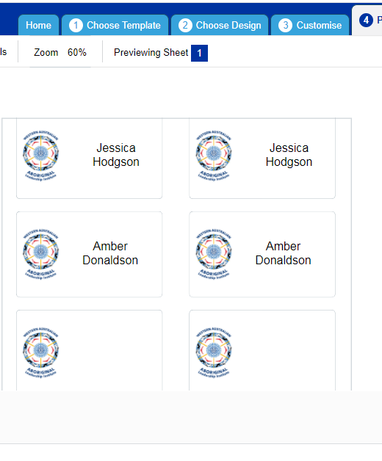

This will ensure that the names appear being on the front and back.
- Cut each name using the guillotine.
- Place individual name tag into the laminating sheet, then cut each, after hole punch and attach to lanyard.
- Set room up 1 hour prior before event with catering, juice, mugs & plates, boiled water for tea, coffee, tables and chairs. Etc.
- Set registration desk up.
- Create signs with arrows to guide guests to venue door as they arrive.
- Regularly clean and tidy kitchen/ tables throughout event, to avoid building up of rubbish.
- Pack up everything once event is over.

How to reconcile fortnightly financial transactions
- Copy & paste transactions into excel spreadsheet from CEO’S email
- Double click A & B column line above to ensure column spreads out to fit data in cells
- Delete rows with banking transfers (e.g row 8)
- Select all columns AFTER C column that have transaction data in it. Once selected, then right click to delete it.
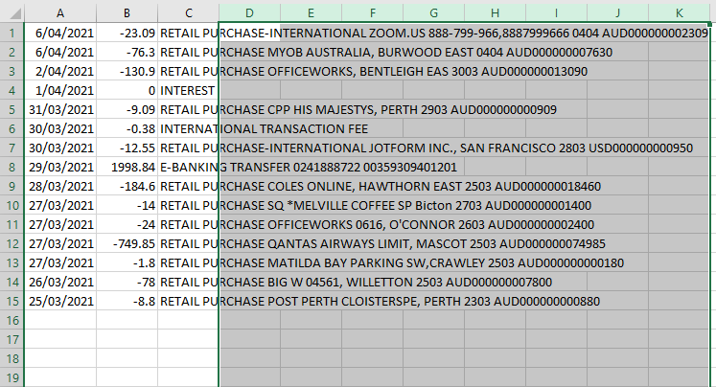

- Once deleted, then double click on top line of the C column.
- Now click on B column and make writing red to show its money being deducted from account. If not make amount green to show its income or interest being received. It should now look like this.
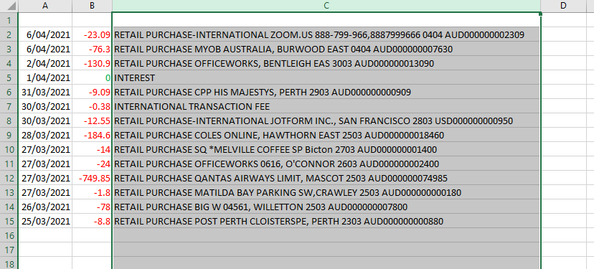

- Now right click on row 1, then click insert
- In column A1 write ‘Date’
In column B1 write ‘Amount’
In column C1 write ‘Transaction’
In column D1 Type ‘Project Name’
In colmn E1 type ‘Project Code’
Should now look like this.
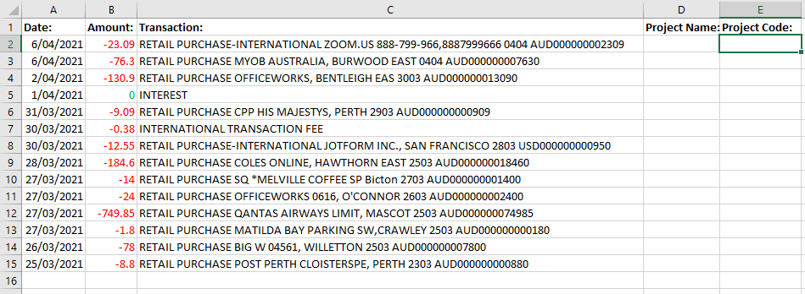

- Now click on column B and on the ‘Home’ page, click the arrow tab where it says ‘general’. Then select ‘currency’.
- Then click on E1 column and on the ‘Home’ page, click the arrow tab where it says ‘general’ and select ‘text’

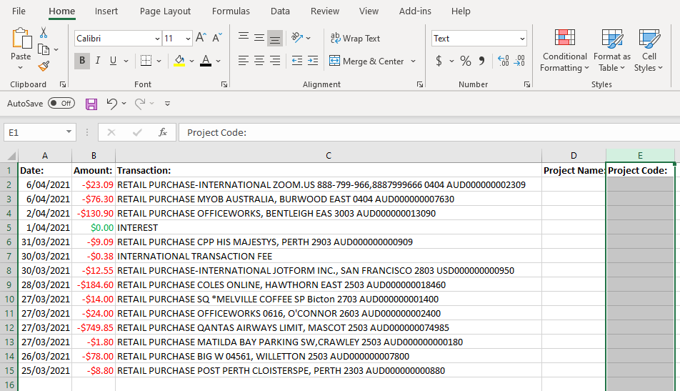

- Now you can start filling out the Project name and code for all transactions. (For account lists refer to page 5 in resources file) Once done click on row 1 to insert another row.
- In this row you will write Debit Card Transactions to the (date), (month) you are reconciling in. for example, Debit Card Transactions to the 7thApril.
- Once done, now select all data and put ‘all borders’
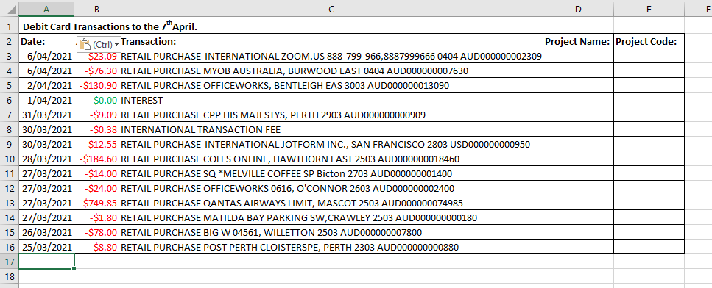

- Now in last cell under the data (A17) write ‘Total Expenditure’.
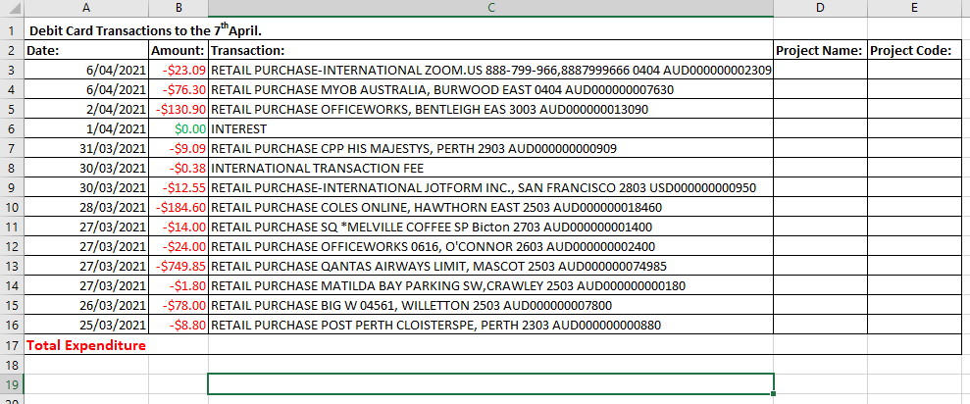

- After you have done this, the last step is to go to the bottom of the B column where it is blank (B17)
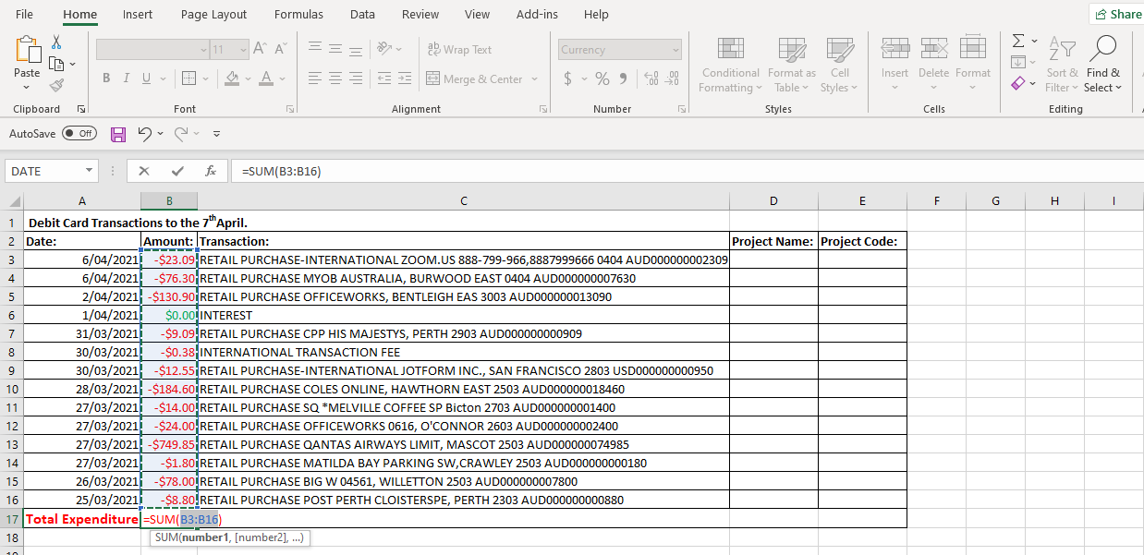
- Then click on the sum icon in the top left-hand corner of the ‘Home’ page.

- Once you have done this, now press enter and you should have the total appear in the cell.
- Now save this doc under the date you reconciled this in (Debit Card Transactions to the 7thApril). In SharePoint>ADMINISTRATION>Finance>Fortnightly reconciled lists>year>month.
- Also send reconciled list doc and scanned receipts doc in email to the CEO.

Bookkeeping Procedure:
- After reconciling list, collate invoices/ receipts that match up to transaction. CEO will provide you with receipts and invoices via email.
- Can use https://www.ilovepdf.com/ to help with merging PDF invoices and scanned receipts together in one document.
- Ensure to collate/scan all invoices and receipts in order to reconciled list. Once done, save this document as ‘’Receipts to the (date)’’ in SharePoint>ADMINISTRATION>Finance>Year>Month>Receipt’s folder.
- Print hard copy of reconciled list along with invoices and collate hard copy receipts in order.
- Once done, then attach behind list and put under relevant month in the WAALI finance folder.

Important meeting dates:
Date: | What Event?
30th April Friday | Yorga Djenna Bidi Module 2 Retreat
4th May Tuesday | Set up for WAALI board meeting at 8:30am
13th May Thursday | Set up for 5:30pm KYAWG Meeting
19th May Thursday | Emerging Leaders meeting at 5:00pm
20th May Thursday | Yorga Djenna Bidi Module 3 Retreat
10th June Thursday | Yorga Djenna Bidi Module 4 Retreat
15th June Tuesday | Set up for WAALI board meeting at 8:30am
24th June Thursday | Set up for KYAWG meeting for 5:30pm
27th July Tuesday | Set up for WAALI board meeting at 8:30am
5th Aug Thursday | Set up for KYAWG meeting for 5:30pm
7th Sep Tuesday | Set up for WAALI board meeting at 8:30am
16th Sep Thursday | Set up for KYAWG meeting for 5:30pm
19th Oct Tuesday | Set up for WAALI board meeting at 8:30am
28th Oct Thursday | Set up for KYAWG meeting for 5:30pm
30th November Tuesday | Set up for WAALI board meeting at 8:30am
9th Dec Thursday | Set up for KYAWG meeting for 5:30pm

Tip: once you have received your email enter all these dates into your calendar

